Year 1 – Plants

National Curriculum Objectives:
* Identify and name a variety of common wild and garden plants, including deciduous and evergreen trees.
* Identify and describe the basic structure of a variety of common flowering plants.
* Identify and name the roots, trunk, branches and leaves of a tree.
Prior Learning: | Working Scientifically Links: | Opportunities for working Scientifically / enquiry: | Story / Book Opportunities: | Maths Opportunities: | Vocabulary:
In EYFS:  - Develop an understanding of growth, decay and changes over time.  - Shows care and concern for living things and the environment.  - Looks closely at similarities, differences, pattern and change.  - Knows about similarities and differences in relation to places, objects, materials and living things (ELG),  Makes observations of animals and plants and explains why some things occur, and can talk about changes | * Closely observe using magnifying glasses.  * Compare and contrast familiar plants.  * Sort and group plants, explaining how they have done this.  * Draw diagrams showing the different parts of plants, including trees.  * Keep records of how plants change over time; e.g. leaves falling off trees and buds opening.  * Compare and contrast what they have found out about different plants. | * What is the plant’s name?  * Can you sort the parts of a plant into the correct groups?  * Which tree has the biggest leaves?  * How can we sort the leaves?  * How does a daffodil bulb change over the year?  * How does the ….. tree change over the year?  * Do trees with bigger leaves lose / get their leaves first?  * Where in our school grounds can we find moss?  * What are the most common British plants? | * Oliver’s Vegetables – Vivienne French  * Little Guide to Wild Flowers – Charlotte Voake  *The Things That I Love about Trees - Chris Butterworth  * Harry’s Hazlenut – Ruth Parsons | Counting leaves  Sorting leaves based on the number of lobes. | leaves, blossom, petals, roots, flower, buds, bulb, trunk, branches, fruit, stem, berry, evergreen, garden plants, deciduous, wild plants, seeds, bark, stalk
 | Types of scientific Enquiry:  Fair & Comparative testing  Research using secondary sources  Identifying, classifying & grouping  Pattern seeking  Observing over time |  | Famous Scientists:  Beatrix Potter (Author & Botanist)
In Year 2: Plants:
* Observe and describe how seeds and bulbs grow into mature plants.
* Find out and describe how plants need water, light and a suitable temperature to grow and stay healthy.
Living Things and their Habitats:
* Identify and name a variety of plants and animals in their habitats, including micro-habitats.
Year 3: Plants:
* Identify and describe the functions of different parts of flowering plants: roots, stem / trunk, leaves and flowers.
* Investigate the way in which water is transported in plants.

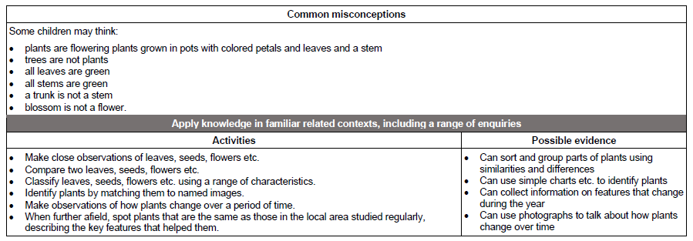
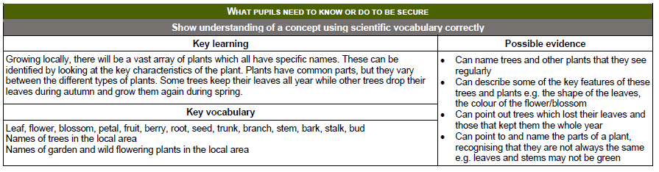
Year 2 – Plants
(Ensure investigations do not overlap with Year 3)
National Curriculum Objectives:
* Observe and describe how seeds and bulbs grow into mature plants.
* Find out and describe how plants need water, light and a suitable temperature to grow and stay healthy.
Prior Learning: | Working Scientifically (NC) Links: | Opportunities for working Scientifically / enquiry | Story Opportunities: | Maths Opportunities: | Vocabulary:
In Year 1:  * Identify and name a variety of common wild and garden plants, including deciduous and evergreen trees.  * Identify and describe the basic structure of a variety of common flowering plants.  * Identify and name the roots, trunk, branches and leaves of a tree. | * Observe and record, with some accuracy, the growth of a variety of plants, as they change over time and grow from a seed / bulb.  * Set up comparative tests to show that plants need light and water to stay healthy. | * How long does it take for seed to grow?  * What conditions are needed for a plant to grow?  * Do cress seeds grow more quickly inside or outside?  * What happens to my bean after I plant it?  * Do bigger seeds grow into bigger plants?  * How does a cactus survive in a desert without water? | Jack and the Beanstalk – Richard Walker  Ten seeds – Ruth Brown  A Seed is Sleepy (Dianna Aston)  Titch – Patch Hutchings  The Tiny Seed – Eric Carle | * Counting seeds.  * Measuring growth over time. | seeds, bulbs, water, light, temperature, growth
 | Types of scientific Enquiry:  Fair & Comparative testing  Research using secondary sources  Identifying, classifying & grouping  Pattern seeking  Observing over time |  | Famous Scientists:  Agnes Arber (Botanist)  Alan Titchmarsh (Botanist & Gardener)
In Year 3:
* Identify and describe different parts of flowering plants: roots, stem / trunk, leaves and flowers.
* Explore the requirements of plants for life and growth (air, light, water, nutrients from the soil, and room to grow) and how they vary from plant to plant.
* Investigate the way in which water is transported in plants.
* Explore the part that flowers play in the life-cycle of flowering plants, including pollination, seed formation and seed dispersal.

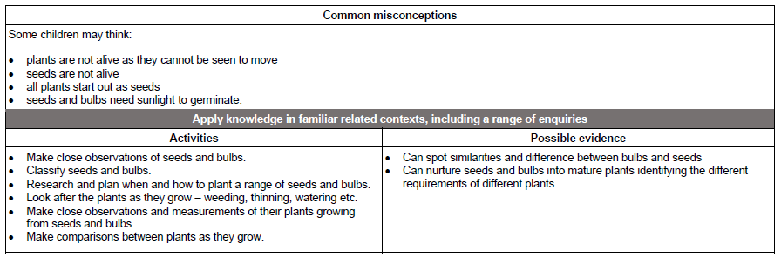
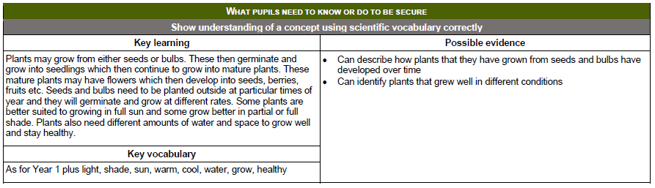

Year 3 – Plants
(Ensure investigation progress from Year 2)
National Curriculum Objectives:
* Identify and describe the functions of different parts of flowering plants: roots, stem / trunk, leaves and flowers.
* Explore the requirements of plants for life and growth (air, light, water, nutrients from the soil, and room to grow) and how they vary from plant to plant.
* Investigate the way in which water is transported in plants.
* Explore the part that flowers play in the life-cycle of flowering plants, including pollination, seed formation and seed dispersal.
Prior Learning: | Working Scientifically Links: | Opportunities for working Scientifically / enquiry | Story Opportunities: | Maths Opportunities: | Vocabulary:
In Year 2:  * Observe and describe how seeds and bulbs grow into mature plants.  * Find out and describe how plants need water, light and a suitable temperature to grow and stay healthy. | * Compare the effect of different factors on plant growth, e.g. the amount of light / fertiliser.  * Observe plants over time to discover how seed are formed by observing the different stages of a plant’s life-cycle over a period of time.  * Look for patterns in the structure of fruit that relate to how the seeds are dispersed.  * Observe how water is carried through the plant using carnations and coloured water. | * What do the different parts of a plant do?  * What is needed for a plant to grow?  * How does water get from the roots to the leaves?  * Why do plants have flowers?  * How does a plant disperse seeds?  * How does the length of a flower stem affect how long it takes for the water to reach the flower?  * What conditions help seeds germinate more quickly?  * How can you sort a group of different plant parts?  * How do flowers change over time? | The story of Frog Belly Ratbone - Timothy Basil Ering  The Hidden Forest – Jeannie Baker  George an Flora’s Secret Garden – Jo  Oh Say You Can Seed by Bonnie Worth  A Tree is a Plant Clyde Robert Bulla | * Measuring growth, time and temperature.  * Measuring volume of water taken up.  * Measuring length of time for spinners to reach the ground. | Air, light, water, nutrients, soil, reproduction, transportation, dispersal, pollination, flower
 | Types of scientific Enquiry:  Fair & Comparative testing  Research using secondary sources  Identifying, classifying & grouping  Pattern seeking  Observing over time |  | Famous Scientists –  Jan Ingenhousz  (Photosynthesis)  Joseph Banks (Botanist)
In Year 5: Living Things and their Habitats:
* Describe the life processes of reproduction in some plants and animals.
In KS3:
* Reproduction in plants, including flower structure, wind and insect pollination, fertilisation, seed and fruit formation and dispersal, including quantitative investigation of some dispersal mechanisms.

