Year 1 – Everyday Materials

National Curriculum Objectives:
* Distinguish between an object and the material from which it is made
* Identify and name a variety of everyday materials, including wood, plastic, glass, metal, water, and rock
* Describe the simple physical properties of a variety of everyday materials
* Compare and group together a variety of everyday materials on the basis of their simple physical properties.

Prior Learning: | Working Scientifically (NC) Links: | Opportunities for working Scientifically: | Story Opportunities: | Maths Opportunities: | Vocabulary:
In EYFS:  * Children should be able to ask questions about the place they live.  * Talk about why things happen and how things work.  * Discuss the things they have observed such as natural and found objects.  * Manipulates materials to achieve a planned effect | * Perform simple tests to explore questions, for example: ‘What is the best material for an umbrella? ...for lining a dog basket? ...for curtains? ...for a bookshelf? ...for a gymnast’s leotard?’ | * How can we sort these items?  * Which material would make the best umbrella?  * Which material would make the best chair?  * Which materials are flexible / rigid / smooth / shiny etc…?  *Which materials can be recycled? | The Three Little Pigs  Cinderella – link to shoes  The Great Paper Caper  (Oliver Jeffers)  Who Sank the Boat  (Pamela Allen) | Sorting hoops | object, material, wood, plastic, glass, metal, rock, brick, water, paper, fabric, elastic, foil, card/cardboard, rubber, wool, clay, hard, soft, stretchy, stiff, bendy, floppy, waterproof, absorbent, breaks / tears, rough, smooth, shiny, dull, see-though, not see-through
Types of scientific Enquiry:
Fair & Comparative testing
Research using secondary sources
Identifying, classifying & grouping
Observing over time
In Year 2:
* Identify and compare the suitability of a variety of everyday materials, including wood, metal, plastic, glass, brick, rock, paper and cardboard for particular uses
* Find out how the shapes of solid objects made from some materials can be changed by squashing, bending, twisting and stretching.

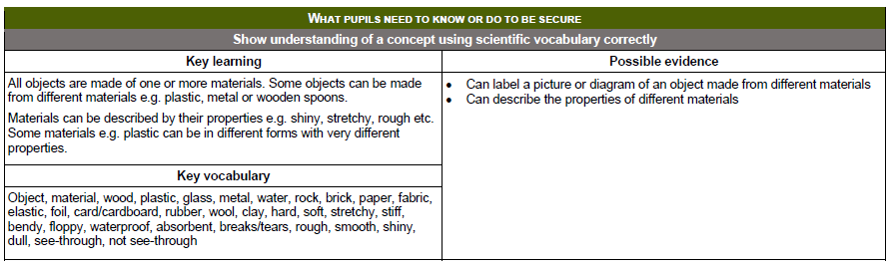
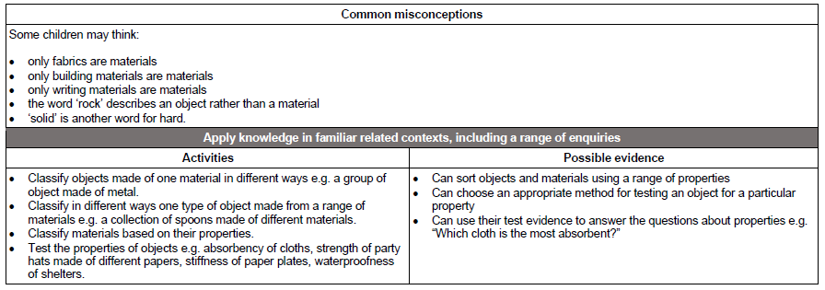
Year 2- Uses of Everyday Materials

National Curriculum Objectives:
* Identify and compare the suitability of a variety of everyday materials, including wood, metal, plastic, glass, brick, rock, paper and cardboard for particular uses
* Find out how the shapes of solid objects made from some materials can be changed by squashing, bending, twisting and stretching.

Prior Learning: | Working Scientifically (NC) Links: | Opportunities for working Scientifically: | Story Opportunities: | Maths Opportunities: | Vocabulary:
In Year 1:  * Distinguish between an object and the material from which it is made  * Identify and name a variety of everyday materials, including wood, plastic, glass, metal, water, and rock  * Describe the simple physical properties of a variety of everyday materials  * Compare and group together a variety of everyday materials on the basis of their simple physical properties. | * Compare use of everyday materials in and around school and other places (link to topic or a story).  * Observe closely; identifying and classifying the use of materials and recording their observations. | * What would be the best material to build a castle from?  * Which materials have been used to build our school?  * How can you change the shape of these materials?  * What materials can you bend and twist?  * How can we group materials by the changes that can be made to them?  * Which material would be best for; the roof of the 3 Little Pigs house, a bucket etc…?  * How have materials we use changed over time? | * The 3 Little Pigs  * The Billy Goats Gruff  * Dragon Wagon  * The Tin Forest  (Helen Ward)  * Traction Man  (Mini Grey) | Tables  Measurement  Venn/ Carroll Diagrams | As Year 1, plus: opaque, transparent, translucent, reflective, non-reflective, rigid, flexible, shape, push/pushing, pull/pulling, twist/twisting, squash/squashing, bend/bending, stretch/stretching
 | Types of scientific Enquiry:  Fair & Comparative testing  Research using secondary sources  Identifying, classifying & grouping  Pattern seeking  Observing over time |  | Famous Scientists:  * William Addis  (Toothbrush inventor)  * Charles Mackintosh (waterproof coat)  * John Macadam  (road construction)
In Year 3:
Rocks and Soils:
* Compare and group together different kinds of rocks based on their appearance and simple physical properties.
Forces and Magnets:
* Notice that some forces need contact between 2 objects, but magnetic forces can act at a distance.
In Year 5:
Properties and Changes of Materials:
* Compare and group together everyday materials on the basis of their properties, including their hardness, solubility, transparency, conductivity (electrical and thermal), and response to magnets.
* Give reasons, based on evidence from comparative and fair tests, for the particular uses of everyday materials, including metals, wood and plastic.

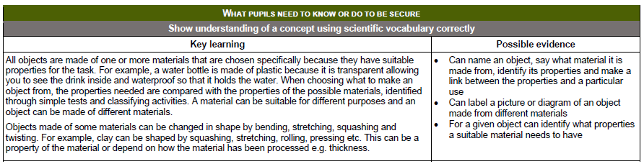

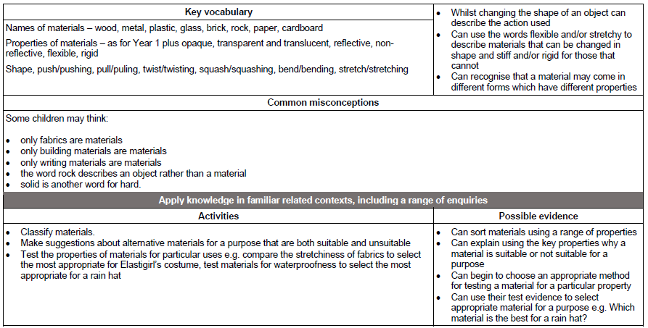
Year 3 – Rocks
National Curriculum Objectives:
* Compare and group together different kinds of rocks on the basis of their appearance and simple physical properties
* Describe in simple terms how fossils are formed when things that have lived are trapped within rock
* Recognise that soils are made from rocks and organic matter.
Prior Learning: | Working Scientifically (NC) Links: | Opportunities for working Scientifically: | Story Opportunities: | Maths Opportunities: | Vocabulary:
In Year 1 – Everyday Materials:  * Distinguish between an object and the material from which it is made.  * Identify and name a variety of everyday materials, including wood, plastic, glass, water, metal and rock.  * Describe the simple physical properties 0f a variety of everyday materials.  * Compare and group together a variety of everyday materials on the basis of their simple physical properties.  In Year 2:  * Identify and compare the suitability of a variety of everyday materials, including wood, metal, plastic, glass, brick, rock, paper and cardboard for particular uses | * Compare and group together different kinds of rocks on the basis of their appearance and simple physical properties.  * Describe in simple terms how fossils are formed when things that have lived are trapped within rock  * Recognise that soils are made from rocks and organic matter. | * How can we group / classify these different rocks based on their physical properties?  * How are rocks formed?  How are fossils formed?  * What is soil made from?  * Which soil drains fastest?  * How does adding sand to soil affect how long water takes to drain through it? | The Pebble in my Pocket – Meredith Hooper  Pebble – a story of belonging – Susan Milord  Stone Underpants – Rebecca Lisle  Stone Girl, Bone Girl  (Laurence Anholt)  The Street Beneath My Feet  (Charlotte Guillain & Yuval Zommer) | Scales – (to order hardness)  Classification key/ venn diagrams/ tables  Measuring the mass or volume of soil | rock, stone, water, soil, pebble, chalk, slate, peat. boulder, grains, sandy / chalky / clay soils, layers, hard, soft, texture, fossils, soils sandstone, granite, marble, pumice, crystals, absorb, absorbent.
 | Types of scientific Enquiry:  Fair & Comparative testing  Research using secondary sources  Identifying, classifying & grouping  Pattern seeking  Observing over time |  | Famous Scientists –  Mary Anning  (Discovery of Fossils)  Inge Lehmann  (Earth’s Mantle)
In Year 6: Evolution and Inheritance:
* Recognise that living things have changed over time and that fossils provide information about living things that inhabited the Earth millions of years ago.
In KS3:
* The composition of the Earth. * The structure of the Earth. * The rock cycle and the formation of igneous, sedimentary and metamorphic rock.

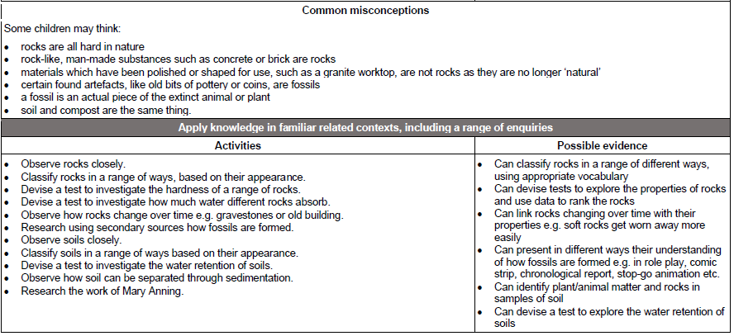
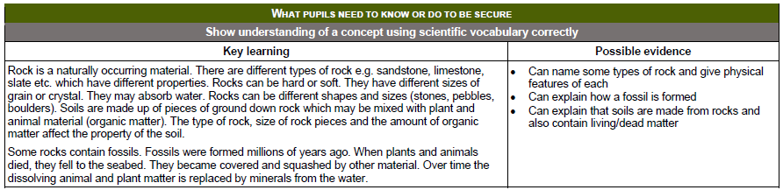
Year 4 – States of Matter
National Curriculum Objectives:
* Compare and group materials together, according to whether they are solids, liquids or gases
* Observe that some materials change state when they are heated or cooled, and measure or research the temperature at which this happens in degrees Celsius (°C)
* Identify the part played by evaporation and condensation in the water cycle and associate the rate of evaporation with temperature.

Prior Learning: | Working Scientifically (NC) Links: | Opportunities for working Scientifically: | Story Opportunities: | Maths Opportunities: | Vocabulary:
In Year 1 – Everyday Materials:  * Distinguish between an object and the material from which it is made.  * Identify and name a variety of everyday materials, including wood, plastic, glass, water, metal and rock.  * Describe the simple physical properties 0f a variety of everyday materials.  * Compare and group together a variety of everyday materials on the basis of their simple physical properties.  In Year 2:  * Identify and compare the suitability of a variety of everyday materials, including wood, metal, plastic, glass, brick, rock, paper and cardboard for particular uses  * Find out how the shapes of solid objects made from some materials can be changed by squashing, bending, twisting and stretching. | * Group and classify a variety of different materials; exploring the effect of temperature on substances such as chocolate, butter, cream (for example, to make food such as chocolate crispy cakes and ice-cream for a party).  * Research the temperature at which materials change state, for example, when iron melts or when oxygen condenses into a liquid.  * Observe and record evaporation over a period of time, for example, a puddle in the playground or washing on a line.  * Investigate the effect of temperature on washing drying or snowmen melting. | * Can you sort these materials into solid, liquid and gases?  * What is the boiling point of different liquids?  * What is the melting point of different materials?  * Where is the best place to dry washing?  * How does temp / mass of the block  affect the speed an ice cube melts?  *Which material is best for keeping our hot chocolate warm?  * How does ice change as it is heated to 100 degrees?  * Is there a pattern between the surface area of a container and how fast water evaporates? | Charlie and the Chocolate Factory  (Roald Dahl)  Once Upon a Raindrop: The Story of Water  (James Carter)  Sticks  (Diane Alber) | Measuring: temperature / time  Tables & Graphs – minutes it takes an ice cube to melt | solid, liquid, gas, state change, melting, freezing, heating, melting, boiling, evaporation, temperature, water cycle, condensation,  particles
 | Types of scientific Enquiry:  Fair & Comparative testing  Research using secondary sources  Identifying, classifying & grouping  Pattern seeking  Observing over time |  | Famous Scientists Anders Celcius (Temp scale)  Daniel Fahrenheit (Temp Scale & Thermometer)
In Year 5:
* Compare and group together everyday materials on the basis of their properties, including their hardness, solubility, transparency, conductivity (electrical and thermal), and response to magnets
* Know that some materials will dissolve in liquid to form a solution, and describe how to recover a substance from a solution
* Use knowledge of solids, liquids and gases to decide how mixtures might be separated, including through filtering, sieving and evaporating
* Give reasons, based on evidence from comparative and fair tests, for the particular uses of everyday materials, including metals, wood and plastic
* Demonstrate that dissolving, mixing and changes of state are reversible changes
* Explain that some changes result in the formation of new materials, and that this kind of change is not usually reversible, including changes associated with burning and the action of acid on bicarbonate of soda.

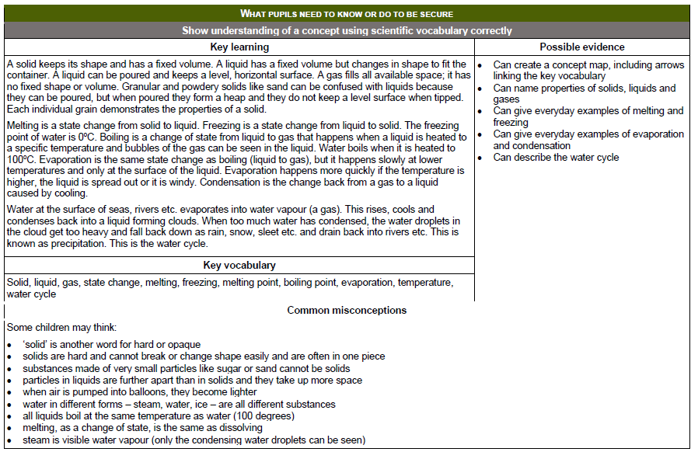
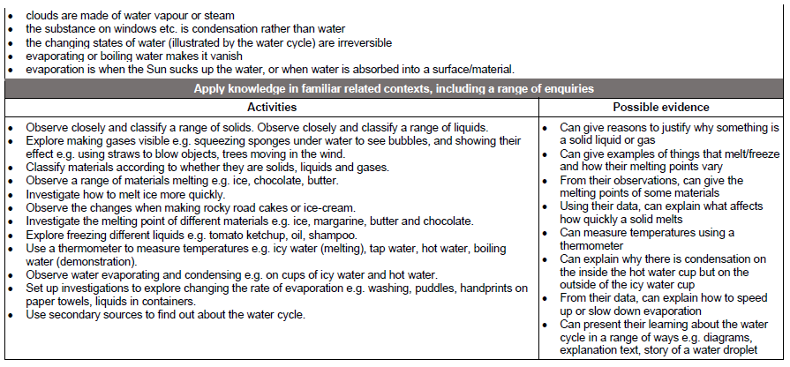
Year 5 – Properties and Changes of Materials.
National Curriculum Objectives:
* Compare and group together everyday materials on the basis of their properties, including their hardness, solubility, transparency, conductivity (electrical and thermal), and response to magnets
* Know that some materials will dissolve in liquid to form a solution, and describe how to recover a substance from a solution
* Use knowledge of solids, liquids and gases to decide how mixtures might be separated, including through filtering, sieving and evaporating
* Give reasons, based on evidence from comparative and fair tests, for the particular uses of everyday materials, including metals, wood and plastic
* Demonstrate that dissolving, mixing and changes of state are reversible changes
* Explain that some changes result in the formation of new materials, and that this kind of change is not usually reversible, including changes associated with burning and the action of acid on bicarbonate of soda.
Prior Learning: | Working Scientifically (NC) Links: | Opportunities for working Scientifically: | Story Opportunities: | Maths Opportunities: | Vocabulary:
In Year 2:  * Identify and compare the suitability of a variety of everyday materials, including wood, metal, plastic, glass, brick, rock, paper and cardboard for particular uses  * Find out how the shapes of solid objects made from some materials can be changed by squashing, bending, twisting and stretching.  In Year 4:  * Compare and group materials together, according to whether they are solids, liquids or gases  * Observe that some materials change state when they are heated or cooled, and measure or research the temperature at which this happens in degrees Celsius (°C)  * Identify the part played by evaporation and condensation in the water cycle and associate the rate of evaporation with temperature. | * Explore and compare the properties of a broad range of materials, including relating these to what they learnt about magnetism in year 3 and electricity in year 4.  * Which materials would be the best for making a warm jacket, wrapping ice cream to stop it melting or for making blackout curtains?  * Compare materials in to make a switch in a circuit.  * Observe and compare changes that take place, e.g. when burning different materials or baking bread / cakes / pancakes.  * Research and compare how chemical changes affect our lives, e.g. when cooking  * Discuss use of new materials, e.g. polymers, super-sticky and super-thin materials. | * Which material is the best thermal insulator?  * How can we separate these materials?  * Which material is the most soluble?  * How can we make sugar dissolve faster?  * Which material would make the best flask?  * How can we make the water clean?  How sweet can you make your tea?  * Which material will make the best coat?  * Which of these experiments can be reversed?  How can you get the salt back from water?  What amount of vinegar / bicarb of soda best inflates the balloon? | Itch – Simon Mayo  Kensuke’s Kingdom – Michael Morpurgo  The BFG – Roald Dahl | * Measurement and reading scales – thermometers  *interpreting scales  * Data logging  * Drawing / interpreting line graphs  * Looking for trends/ patterns | thermal / electrical insulator / conductor, change of state, mixture, dissolve, solution, soluble, insoluble, filter, sieve, reversible / non-reversible change, burning, rusting, new materials, hardness, solubility, transparency, magnetic, evaporate
 | Types of scientific Enquiry:  Fair & Comparative testing  Research using secondary sources  Identifying, classifying & grouping  Pattern seeking  Observing over time |  | Famous Scientists –  Spencer Silver,  Arthur Fry and Alan Amron (Post-it notes)  Ruth Benerito  (Wrinkle-Free Cotton)
In KS3: * Chemical reactions as the re-arrangement of atoms. * Representing chemical reactions using formulae and equations. * Combustion, thermal decomposition, oxidation and displacement reactions. * Defining acids and alkalis in terms of neutralisation reactions. * The pH scale for measuring acidity / alkalinity and indicators.
