Year 2 – Living Things and Their Habitats.

National Curriculum Objectives:
* Explore and compare the differences between things that are living, dead and things that have never been alive.
* Identify that most living things live in habitats to which they are suited and describe how different habitats provide for the basic needs of different kinds of animals and plants, and how they depend on each other.
* Identify and name a variety of plans and animals in their habitats, including micro-habitats.
* Describe how animals obtain their food from plants and other animals, using the idea of a simple food chain, and identify and name different sources of food.
Prior Learning: | Working Scientifically Links: | Opportunities for working Scientifically: | Story / Book Opportunities: | Maths Opportunities: | Vocabulary:
In EYFS:  * Knows and similarities and differences in relation to places, objects, materials and living things.  * Looks closely at similarities, differences, patterns and change,  * Makes observations of animals and plants and explain why some things occur, and talk about changes.  In Year 1:  Plants:  * Identify and name a variety of common plants.  * Identify and describe the basic structure of a variety of common flowering plants, including trees.  Animals including humans:  * Identify and name a variety of common animals, including fish, amphibians, reptiles, birds and mammals.  * Identify and name a variety of common animals that are herbivores, carnivores and omnivores.  * Describe and compare the structure of a variety of common animals.  Seasonal Changes:  * Observe changes across the 4 seasons. | * Sort and classify as living, dead, never-alive – record using charts.  * Describe how they decided where to place things.  * Explore questions such as, Is a flame alive? Are deciduous trees dead in winter? Consider ways to answer these.  * Simple food chains including humans e.g. grass cow human  *Describe conditions in different habitats / micro-habitats and find out how they affect the number and type of plants / animals that live there. | * Can you sort these things into; living, dead and ever been alive?  * How are they similar / different?  * Micro-habitat hunt – what lives in each and why?  * What lives in….. (desert, arctic etc..) and how is it suited?  * How can we make a home for a……..? (bug hotel)  * Do cress seeds grow more quickly inside or outside? Is this always the case?  * How does the school pond change over the year? | The Gruffalo (Julia Donaldson)  Meerkat Mail (Emily Gravett)  No Place Like Home  (Jonathon Emmett) | Charts / Tables  Venn diagrams  Classification keys | living, dead, never been alive, suited, suitable, basic needs, food chain, shelter, move, feed, names of local habitats, e.g. pond, field, woodland etc, names of micro-habitats e.g. under logs, in the bushes etc
 | Types of scientific Enquiry:  Fair & Comparative testing  Research using secondary sources  Identifying, classifying & grouping  Pattern seeking  Observing over time |  | Famous Scientists:  Terry Nutkins – TV Presenter  Liz Bonnin - Consevationist
In Year 4: Living things and their Habitats: * Recognise that living things can be grouped in a variety of ways.
* Explore and use classification keys to help, group, identify and name a variety of living things in their local and wider environment.
* Recognise that environments change and that this can sometimes pose dangers to living things.
Animals including humans: * Construct and interpret a range of food chains, identifying producers, predators and prey.
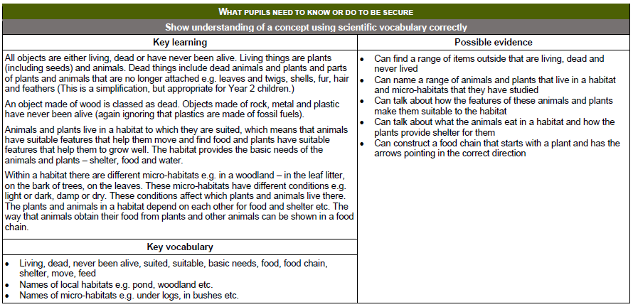

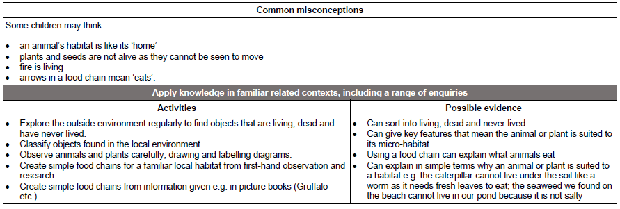

Year 4 – Living Things and Their Habitats.
National Curriculum Objectives:
* Recognise that living things can be grouped in a variety of ways.
* Explore and use classification keys to help, group, identify and name a variety of living things in their local and wider environment.
* Recognise that environments change and that this can sometimes pose dangers to living things (include human impact).
Prior Learning: | Working Scientifically Links: | Opportunities for working Scientifically: | Story / Book Opportunities: | Maths Opportunities: | Vocabulary:
In Year 1:  Plants:  * Identify and name a variety of common, wild and garden plants, including deciduous and evergreen trees.  * Identify and describe the basic structure of a variety of common flowering plants, including trees.  Animals including humans:  * Identify and name a variety of common animals, including fish, amphibians, reptiles, birds and mammals.  *Describe and compare the structure of a variety of common animals.  In Year 2:  Living things and their habitats:  * Identify and name a variety of plans and animals in their habitats, including micro-habitats. | * Use or make simple guides or keys to explore and identify local plants and animals.  * Make a guide to local living things.  * Raise and answer question based on animals and what they have found out about other animals they have researched. | * How has local area / school grounds changed? (Create a hypothetical scenario, e.g. selling off the school field).  * Research climate change  * How does the greenhouse effect change temperature and contribute to climate change?  *Can you identify all the things we saw in the…….  * Why are people cutting down the rainforest and what effect does it have?  * Does the amount of light affect woodlice activity?  * How can we make positive changes to a local environment for living things?  * How do you know ……. (ants / ladybirds) are both … …… (insects)?  * How can you sort these living things? | The Vanishing Rainforest (Richard Platt)  The Morning I Met a Whale (Michael Morpurgo)  Journey to the River Sea (Eva Ibbotson) | Interpret and present discrete and continuous data using graphs (bar graphs / time graphs)  Record data in tables | classificationclassification keys, environment habitat, human impact, positive, negative, migrate, hibernate
 | Types of scientific Enquiry:  Fair & Comparative testing  Research using secondary sources  Identifying, classifying & grouping  Pattern seeking  Observing over time |  | Famous Scientists:  Cindy Looy (Environmental change and extinction)  Jaques Cousteau  Marine Biologist
In Year 5: Living things and their habitats:
* Describe the difference in the life-cycles of a mammal, an amphibian, an insect and a bird.
* Describe the life processes of reproduction in some plans and animals.
In Year 6: Living things and their habitats:
* Describe how living things are classified into broad groups according to common observable characteristics and based on similarities and differences, including micro-organisms, plants and animals.
* Give reasons for classifying plants and animals based on specific characteristics.
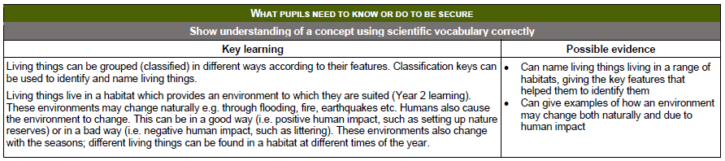

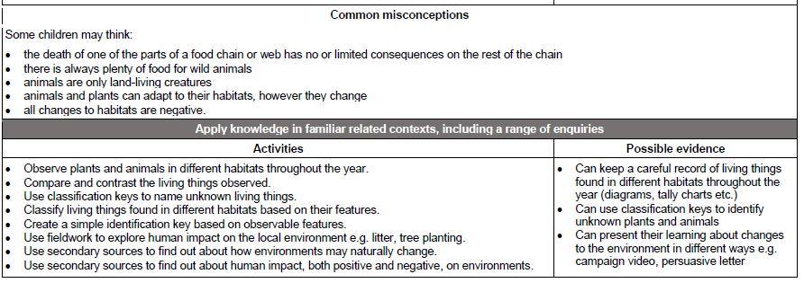

Year 5 – Living Things and Their Habitats.

National Curriculum Objectives:
* Describe the difference in the life-cycles of a mammal, an amphibian, an insect and a bird.
* Describe the life processes of reproduction in some plans and animals.
Prior Learning: | Working Scientifically Links: | Opportunities for working Scientifically: | Story / Book Opportunities: | Maths Opportunities: | Vocabulary:
In Year 2:  Animals, including humans:  * Notice that animals, including humans, have offspring which grow into adults.  In Year 3:  Plants:  Explore the part that flowers play in the life cycle of flowering plants, including pollination, seed formation and seed dispersal. | * Observe and compare the life cycles of plants and animals in their local environment with other plants and animals around the world (rainforest, oceans, desert areas, prehistoric times), asking pertinent questions and suggest reasons for similarities and differences.  * Grow new plants from different parts of the parent plant, eg; seeds, stem and root cuttings, tubers, bulbs.  * Observe changes in an animal over a period of time, comparing how different animals reproduce and grow. | * What can you find out about the different stages in the life-cycles of different animals?  * How do ……… change over time?  * Do all ….. (mammals / birds / insects etc …) develop in the same way?  * How do different animals develop as they get older?  * How do bird eggs change over time?  * What are the functions of the different parts of a flower?  * How do flowers change over time?  * Which flowers have the strongest smell? | Charlotte’s Web (E.B. White)  The Land if Never believe (Norman Messenger)  Mummy Laid an Egg (Babette Cole) | Tables  Accurate measuring | life cycle, reproduce, sexual, sperm, fertilises, egg, live young, metamorphosis, asexual, plantlets, runners, bulbs, cuttings
 | Types of scientific Enquiry:  Fair & Comparative testing  Research using secondary sources  Identifying, classifying & grouping  Pattern seeking  Observing over time |  | Famous Scientists  David Attenborough  (Naturalist)  James Brodie of Brodie (reproduction of plants by spores)
Future Learning: In KS3:
* Reproduction in humans (as example of a mammal), including the structure and function of the male and female reproductive systems, menstrual cycle, gametes, fertilisation, gestation and birth, to include the effect of maternal lifestyle on the foetus through the placenta.
* Reproduction in plants, including flower structure, wind and insect pollination, fertilisation, seed and fruit formation and dispersal, including quantitative investigation of some seed dispersal mechanisms.

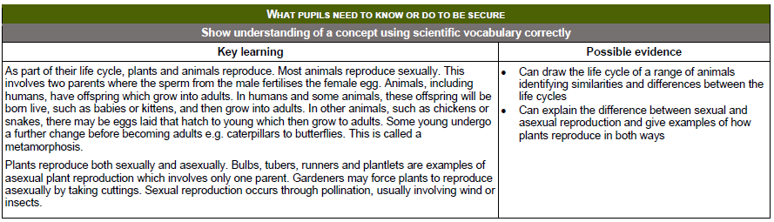

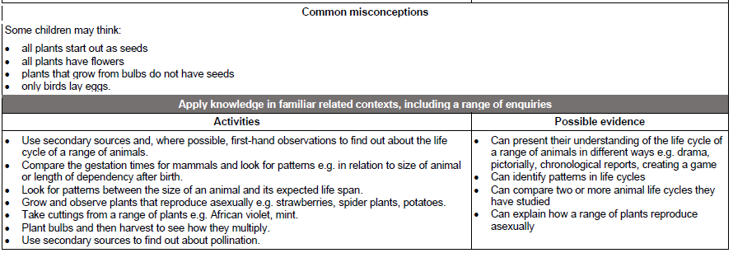

Year 6 – Living Things and Their Habitats.

National Curriculum Objectives:
* Describe how living things ae classified into broad groups according to common observable characteristics and based on similarities and differences, including micro-organisms, plants and animals.
* Give reasons for classifying plants and animals based in specific characteristics.
Prior Learning: | Working Scientifically Links: | Opportunities for working Scientifically: | Story / Book Opportunities: | Maths Opportunities: | Vocabulary:
In Year 4:  Living things and their habitats:  * Recognise that living things an be grouped in a variety of ways.  * Explore and use classification keys to help group, identify and name a variety of living things in their local and wider environment.  In Year 5:  Living things and their habitats:  * Describe the difference in the life-cycles of a mammal, an amphibian, an insect and a bird.  * Describe the life processes of reproduction in some plants and animals. | * Use classification systems and keys to identify plants and animals in the immediate environment.  * Research unfamiliar animals form a broad range of habitats and decide where they belong in the classification system. | * Can you classify these living things?  * Who is the most related (in a set of 3 living things)  *Can you design a classification key to identify leaves in the local environment?  * What happens to a piece of bread if you leave it on the window sill for 2 weeks? | Beetle Boy (M G Leonard)  Insect Soup (Barry Louis Polisar)  Fur and Feathers (Janet Halfmann) | * Use of branching diagrams / classification keys | vertebrates, fish, amphibians, reptiles, birds, mammals, invertebrates, insects, spiders, snails, worms, flowering and non-flowering
 | Types of scientific Enquiry:  Fair & Comparative testing  Research using secondary sources  Identifying, classifying & grouping  Pattern seeking  Observing over time |  | Famous Scientists  Carl Linnaeus  (Identifying, Naming and Classifying Organisms)
Future Learning:
In KS3: Differences between species.

