Year 3 - Light and Sound

National Curriculum Objectives:
* Recognise that they need light in order to see thigs and that dark is the absence of light.
* Notice that light is reflected from surfaces.
* Recognise that light from the sun can be dangerous and that there are ways to protect their eyes.
* Recognise that shadows are formed when the light from a light source is blocked by an opaque object.
* Find patterns in the way that sizes of shadows change.
Prior Learning: | Working Scientifically Links: | Opportunities for working Scientifically: | Story / Book Opportunities: | Maths Opportunities: | Vocabulary:
In Year 1: Animals Including Humans:  * Identify, name, draw and label the basic parts of the human body and say which part of the body is associated with each sense. | * Look for patterns in what happens to shadows when the light source moves.  * Look for patterns in what happens to shadows when the distance between the light source and the object changes. | * Which is the best material for a mirror?  * Which is the best material for sunglasses?  * Do cats’ eyes light up in the dark? (Link to luminous and non-luminous)  * Why can we see fireworks better in the dark?  * When is our classroom the darkest?  * How does the distance between the shadow puppet and screen affect the shadow?  * How can you sort these different light sources?  * Are you more likely to need glasses as you get older? | The Dark (Lemony Snicket)  Barnaby Bear  Cat Story  The Firework-maker’s daughter (Phillip Pullman)  The Owl Who was Afraid of the Dark (Jill Tomlinson) | Data handling  Data Measuring | Light, light source, dark, absence of light, transparent, translucent, opaque, shiny, matt, surface, shadow, reflect, mirror, sunlight, dangerous, visible, beam,  (luminous,  non-luminous)
 | Types of scientific Enquiry:  Fair & Comparative testing  Research using secondary sources  Identifying, classifying & grouping  Pattern seeking  Observing over time |  | Famous Scientists:  James Clerk Maxwell  (Visible and Invisible Waves of Light)
In Year 6:
* Recognise that light appears to travel in straight lines.
* Use the idea that light travels in straight lines to explain that objects are seen because they give out light or reflect light into the eye.
* Explain that we see things because light travels from light sources to our eyes or from light sources to objects and then to or eyes.
* Use the idea that light travels in straight lines to explain why shadows have the same shape as the objects that cast them.

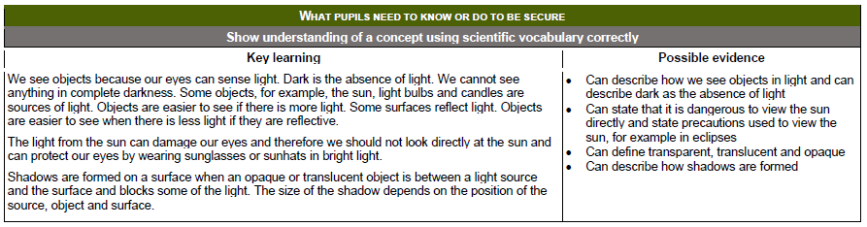
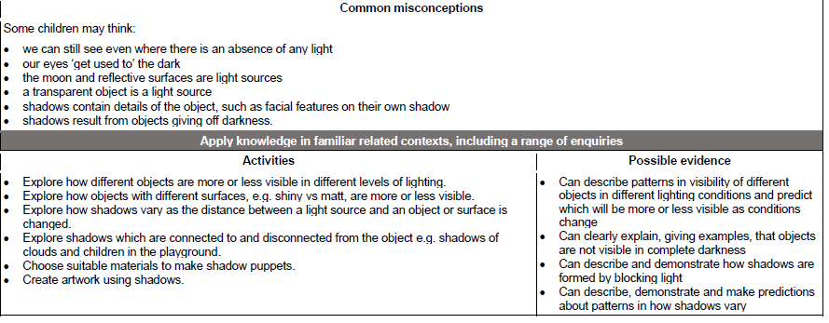
Year 4 - Light and Sound

National Curriculum Objectives:
* Identify how sound are made, associating some of them with something vibrating.
* Recognise that vibrations from sounds travel through a medium to the ear.
* Find patterns between the pitch of a sound and features of the object that produced it.
* Find patterns between the volume of a sound and the strength of the vibrations that produced it.
* Recognise that sounds get fainter as the distance from the sound source increases.
Prior Learning: | Working Scientifically Links: | Opportunities for working Scientifically: | Story / Book Opportunities: | Maths Opportunities: | Vocabulary:
In Year 1: Animals Including Humans:  * Identify, name, draw and label the basic parts of the human body and say which part of the body is associated with each sense. | * Find patterns in the sounds that are made by different objects such as saucepan lids of different sizes or elastic bands of different thicknesses.  * Make earmuffs from different materials to investigate which provides the best insulation from sound.  * Make their own instruments by using what they have found out about pitch and volume. | * Cups and string – children to ask their own questions to investigate.  * Can you make a guitar that makes 4 different pitches?  * What is the effect of the distance from the source on the volume / amplitude of a sound?  * How does the length of a guitar string / tuning fork affect the pitch of the sound?  * Sort the materials according to the sound they make when struck. | Horrid Henry Rocks  (Francesca Simon)  Moonbird  (Joyce Dunbar)  The Pied Piper of Hamelin  (Natalia Vasquez) | Measuring -length of string / elastic band  Data logger – record decibels | sound, source, vibrate, vibration, travel, pitch (high, low), volume, faint, loud, insulation, amplitude, sound wave
 | Types of scientific Enquiry:  Fair & Comparative testing  Research using secondary sources  Identifying, classifying & grouping  Pattern seeking  Observing over time |  | Famous Scientists:  Aristotle  (Sound Waves)  Gailileo Galilei  (Frequency and Pitch of Sound Waves)  Alexander Graham Bell  (Telephone)
In KS3:
* Waves on water as undulations which travel through water with transverse motion; these waves can be reflected, and add or cancel – superposition.
* Frequencies of sound waves, measured in Hertz; echoes, reflection and absorption of sound.
* Sound needs a medium to travel, the speed of sound in air, in water, in solids.
* Sound produced by vibrations of objects, in loud speakers, detected by their effects on microphone diaphragm and the eardrum; sound waves are longitudinal.
* Auditory range of humans and animals.
* Pressure waves transferring energy; use for cleaning and physiotherapy by ultra-sound.
* Waves transferring information for conversion to electrical signals by microphone.

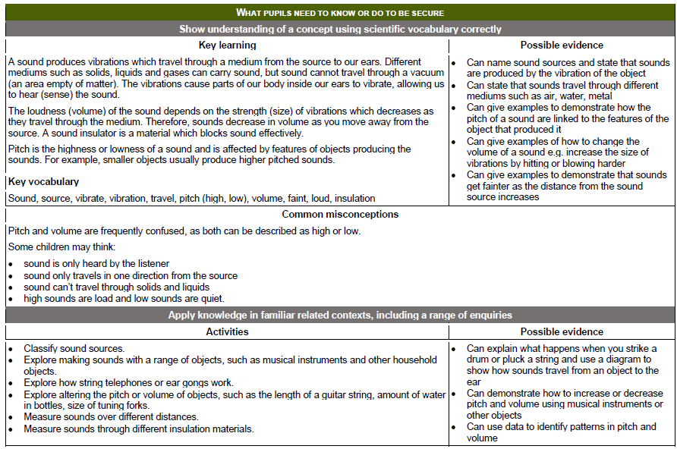

Year 6 - Light and Sound

National Curriculum Objectives:
* Recognise that light appears to travel in straight lines.
* Use the idea that light travels in straight lines to explain that objects are seen because they give out light or reflect light into the eye.
* Explain that we see things because light travels from light sources to our eyes or from light sources to objects and then to our eyes.
* Use the idea that light travels in straight lines to explain why shadows have the same shape as the objects that cast them.
Prior Learning: | Working Scientifically Links: | Opportunities for working Scientifically: | Story / Book Opportunities: | Maths Opportunities: | Vocabulary:
In Year 3:  * Recognise that they need light in order to see thigs and that dark is the absence of light.  * Notice that light is reflected from surfaces.  * Recognise that light from the sun can be dangerous and that there are ways to protect their eyes.  * Recognise that shadows are formed when the light from a light source is blocked by an opaque object.  * Find patterns in the way that sizes of shadows change. | * Decide where to place rear-view mirrors on cars, design and make a periscope and explain how these work.  * Investigate the relationship between light sources, objects and shadows.  * Extend their experience of light by looking at a range of phenomena; rainbows, colours in bubbles, objects looking bent in water and coloured filters. | * How does the angle that a light ray hits a plane mirror affect the angle at which it reflects off the surface? Apply this to periscopes and rear-view mirrors.  * Which material is most reflective? | Letters from the Lighthouse  (Emma Carroll)  The Gruffalo’s Child  (Julia Donaldson)  The King Who Banned the Dark  (Emily Haworth-Booth) | Angles – use of a protractor  Converting units of measure | As for Year 3 plus:  straight lines, light rays, scattered, refraction
 | Types of scientific Enquiry:  Fair & Comparative testing  Research using secondary sources  Identifying, classifying & grouping  Pattern seeking  Observing over time |  | Famous Scientists:  Thomas Young  (Wave Theory of Light)  Ibn al-Haytham (Alhazen)  (Light and our Eyes)  Percy Shaw  (The Cats Eye)
In KS3:
* The similarities and differences in light waves and waves in matter.
* Light waves travelling through a vacuum; speed of light.
* The transmission of light waves through materials; absorption, diffuse scattering and specular reflection at a surface.
* Use of a ray model to explain imaging in mirrors, the pinhole camera, the refraction of light and action of convex lens in focusing; the human eye.
* Light transferring energy from source to absorber leading to chemical and electrical effects; photo-sensitive in the retina and in cameras.
* Colour and the different frequencies of light, white light and prisms; differential colour effects in absorption and diffuse reflection.

