Year 1 – Animals Including Humans

National Curriculum Objectives:
* identify and name a variety of common animals including fish, amphibians, reptiles, birds and mammals (NB – children need to be able to name common animals from these groups. They DO NOT need to know the names of the groups, e.g. Amphibian, reptile etc or the key characteristics of each group)
* identify and name a variety of common animals that are carnivores, herbivores and omnivores
* describe and compare the structure of a variety of common animals (fish, amphibians, reptiles, birds and mammals, including pets)
* identify, name, draw and label the basic parts of the human body and say which part of the body is associated with each sense.

Prior Learning: | Working Scientifically (NC) Links: | Opportunities for working Scientifically: | Story / Book Opportunities: | Maths Opportunities: | Vocabulary:
In EYFS:  - Knows about similarities and differences in relation to places, objects, materials and living things.  - Makes observations of animals and plants and explains why some things occur, and talk about changes.  - Knows the importance for good health of physical exercise, and a healthy diet, and talks about ways to keep healthy and safe. | *Use observations to compare and contrast animals at first hand or through videos or photos.  * Describe how they identify and group animals  * use senses to compare different textures, sounds and smells.  * group animals according to what they eat. | * Which parts of my body are involved in my senses?  * Which sense do I use to …?  *What do I use my ……… for?  * Where is my ….?  * Just because I am older, am I taller?  * Is our sense of smell better when we can’t see?  * How can we sort the animals?  * What are the names of these body parts?  * How does my height change over the year?  * Do you get better at smelling as you get older?  * Do all animals have the same senses as humans? | *RSPB: My First Book of Garden Birds (Mike Unwin & Sarah Whittley)  * Snail Trail (Ruth Brown)  * Superworm (Julia Donaldson & Axel Scheffler)  * Look Out! How we use our five senses (Kidwow)  * The growing story Ruth Krauss | * Bar chart  * Counting in 2s, 5s, 10s  * Venn Diagram | (amphibians, birds, fish, mammals, reptiles, carnivores, herbivore, omnivore – these may be used but are not a requirement) sight, hearing, touch, taste, smell, head, neck, ear, mouth, shoulder, hand, fingers, leg, foot, thumb, eye, nose, knee, toes, teeth, elbow Head, body, eyes, ears, mouth, teeth, leg, tail, wing, claw, fin, scales, feathers, fur, beak, paws, hooves
 | Types of scientific Enquiry:  Fair & Comparative testing  Research using secondary sources  Identifying, classifying & grouping  Pattern seeking  Observing over time |  | Famous Scientists:  Chris Packham (Animal Conservationist)
In Year 2: Living Things and their Habitats:
* Describe how animals obtain their food from plants and other animals, using the idea of a simple food chain, and identify and name different sources of food.
In Year 6: Living Things and Their Habitats:
* Describe how living things are classified into broad groups according to common observable characteristics, and based on similarities and differences, including micro-organisms, plants and animals.
* Give reasons for classifying plants and animals based on specific characteristics.
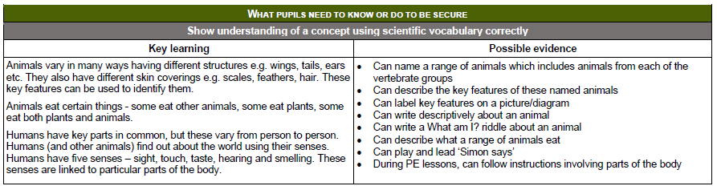
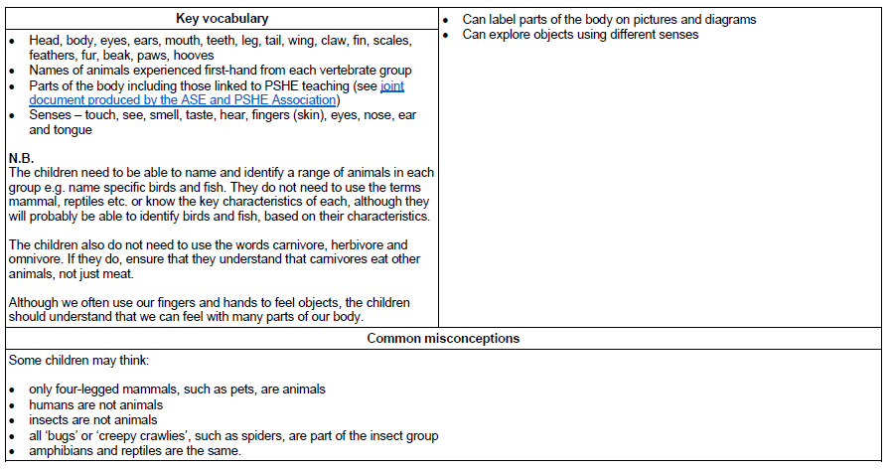
Year 2 – Animals Including Humans
National Curriculum Objectives:
* notice that animals, including humans, have offspring which grow into adults
* find out about and describe the basic needs of animals, including humans, for survival (water, food and air)
* describe the importance for humans of exercise, eating the right amounts of different types of food, and hygiene.

Prior Learning: | Working Scientifically (NC) Links: | Opportunities for working Scientifically: | Story Opportunities: | Maths Opportunities: | Vocabulary:
In Year 1:  * identify and name a variety of common animals including fish, amphibians, reptiles, birds and mammals  * identify, name, draw and label the basic parts of the human body and say which part of the body is associated with each sense. | * Observe- through video or first-hand and measurement how different animals, including humans, grow.  * Ask questions about what animals need for survival and what humans need to stay healthy.  * Suggest ways to find answers to these questions. | * Which foods are healthy / unhealthy?  * Why are some foods unhealthy?  * How do I keep healthy?  * What do living things need to survive?  * Could I survive without?  * Which offspring belongs to which animal?  * How does a tadpole develop?  * Is my diet healthy / unhealthy? | * Handa’s Surprise (Eileen Brown)  * Once there were Giants (Martin Waddell & Penny Dale)  * Tadpole’s Promise (Jeanne Willis & Tony Ross) | * Venn / Carroll diagrams  * Tables  * Measurement | Survival, Water, Air, Food, Adult, Baby, Offspring, Kitten, Calf, Puppy, Exercise, Hygiene
 | Types of scientific Enquiry:  Fair & Comparative testing  Research using secondary sources  Identifying, classifying & grouping  Pattern seeking  Observing over time |  | Famous Scientists:  Steve Irwin – Crocodile Hunter  Robert Winston – Human Scientist  Joe Wicks -Personal Trainer

In Year 3: Animals including Humans:
* identify that animals, including humans, need the right types and amount of nutrition, and that they cannot make their own food; they get nutrition from what they eat.
In Year 5: Living Things and their Habitats:
* Describe the differences in the life-cycle of a mammal, an amphibian, an insect and a bird.
* Describe the life processes of reproduction in some plants and animals.
In Year 6: Animals, including Humans:
* Recognise the impact of diet, exercise, drugs and lifestyle on the way their bodies function.
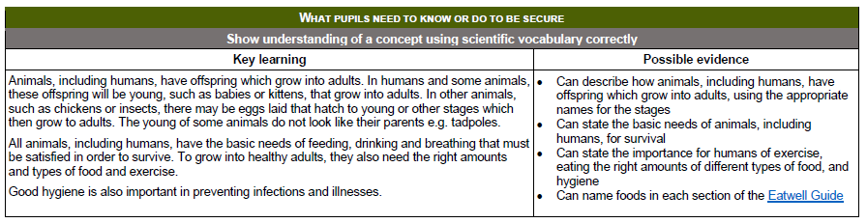

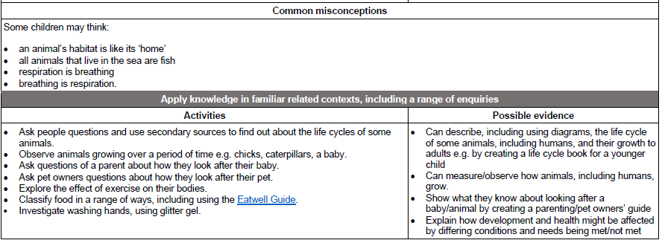

Year 3 – Animals Including Humans

National Curriculum Objectives:
* identify that animals, including humnas, need the right types and amount of nutrition and that they cannot make their own food; hey get nutrition from what they eat.
* identify that humans and some other animals have skeletons and muscles for support, protection and movement.
Prior Learning: | Working Scientifically (NC) Links: | Opportunities for working Scientifically: | Story Opportunities: | Maths Opportunities: | Vocabulary:
In Year 1:  * identify and name a variety of common animals including fish, amphibians, reptiles, birds and mammals  * identify and name a variety of common animals that are carnivores, herbivores and omnivores  * describe and compare the structure of a variety of common animals (fish, amphibians, reptiles, birds and mammals, including pets)  In Year 2:  * find out about and describe the basic needs of animals, including humans, for survival (water, food and air)  * describe the importance for humans of exercise, eating the right amounts of different types of food, and hygiene. | * Identify and group animals with and without skeletons, observe and compare their movement.  * Explore ideas about what would happen if humans did not have skeletons.  * Compare and contrast diets of different animals (inclu. pets) and decide ways to group them according to what they eat.  * Research different food groups and how they keep us healthy. Use this to plan healthy meals. | * Why do I need to ….. to be healthy?  * What would happen if I didn’t have a skeleton / any muscles?  *Child lead investigations focusing on muscles. E.g.  - Do children who do more sport have stronger muscles?  - Do girls / boys have bigger heads?  - Do taller children have larger feet?  * How do the skeletons of different animals differ?  * How does our skeleton change over our lifetime? | * Funnybones (Janet & Allan Ahlberg)  * I will Never Not Ever Eat a Tomato (lauren Child)  * Goldilocks and the 3 Bears (Samantha Beger) | * Examine food labels, reading and comparing information about amount of sugar, fat, carbohydrates, etc. that in different products.  * Show that bones are living and growing by carrying out a survey on bone length across the school. Discuss how the measures between year groups are 2 times as long etc. | movement, muscles, bones, skull, nutrition, skeletons
 | Types of scientific Enquiry:  Fair & Comparative testing  Research using secondary sources  Identifying, classifying & grouping  Pattern seeking  Observing over time |  | Famous Scientists –  Adelle Davis  (20th Century Nutritionist)  Marie Curie  (Radiation / X-Rays)
In Year 4:
* describe the simple functions of the parts of the digestive system in humans.
* identify the different types of teeth in humans and their functions.
* Construct and interpret a variety of food chains, identifying producers, predators and prey.
In Year 6:
* Recognise the impact of diet, exercise, drugs and lifestyle have on their bodies.

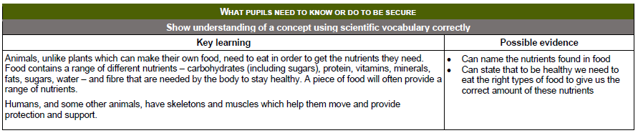
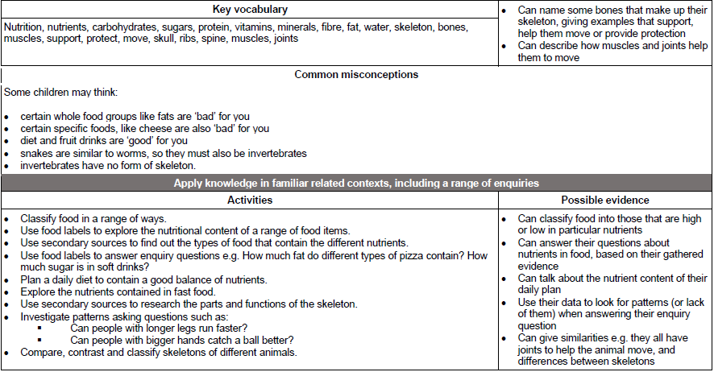
Year 4 – Animals Including Humans

National Curriculum Objectives:
* describe the simple functions of the basic parts of the digestive system in humans
* identify the different types of teeth in humans and their simple functions
* construct and interpret a variety of food chains, identifying producers, predators and prey.

Prior Learning: | Working Scientifically (NC) Links: | Opportunities for working Scientifically: | Story Opportunities: | Maths Opportunities: | Vocabulary:
In Year 1:  * Identify and name a variety of common animals that are carnivores, herbivores and omnivores.  In Year 2:  * Find out about and describe the basic needs of animals, including humans, for survival.  * Describe the importance for humans of exercise, eating the right amounts of different food and hygiene.  In Year 3:  * identify that animals, including humans, need the right types and amount of nutrition, and that they cannot make their own food; they get nutrition from what they eat | * Compare the teeth of carnivores and herbivores - suggest reasons for differences.  *Find out what damages teeth and how to look after them.  * Draw and discuss ideas about the digestive system and compare them with models and images. | * Why do we have different teeth?  * Can you guess this animal’s diet from its teeth?  * What happens to our food?  * Which part of the digestive system does the most important job? (You could do an organ job interview)  *How do different drinks affect our teeth?  * Do animals at the top / bottom of a food chain have anything in common? | * Human Body Odyssey (Werner Holzwarth)  * Crocodiles Don’t Brush Their Teeth (Colin Fancy)  * Wolves (Emily Gravett) |  | Mouth, Tongue, Teeth, Oesophagus, Stomach, Small Intestine, Large Intestine, Herbivore, Carnivore, Canine, Incisor, Molar
 | Types of scientific Enquiry:  Fair & Comparative testing  Research using secondary sources  Identifying, classifying & grouping  Pattern seeking  Observing over time |  | Famous Scientists –  Ivan Pavlov  (Digestive System Mechanisms)  Joseph Lister  (Discovered Antiseptics)
In Year 6:
*Identify and name the main parts of the human circulatory system, and describe the functions of the heart, blood vessels and blood.
*Recognise the impact of diet, exercise and drugs and lifestyle on the way their bodies function.
*Describe the ways in which nutrients and water are transported within animals, including humans.

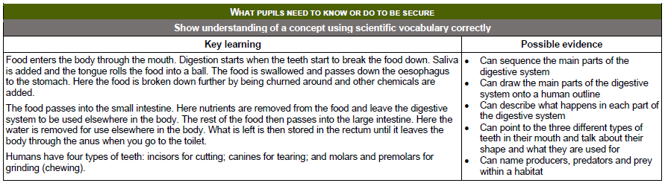

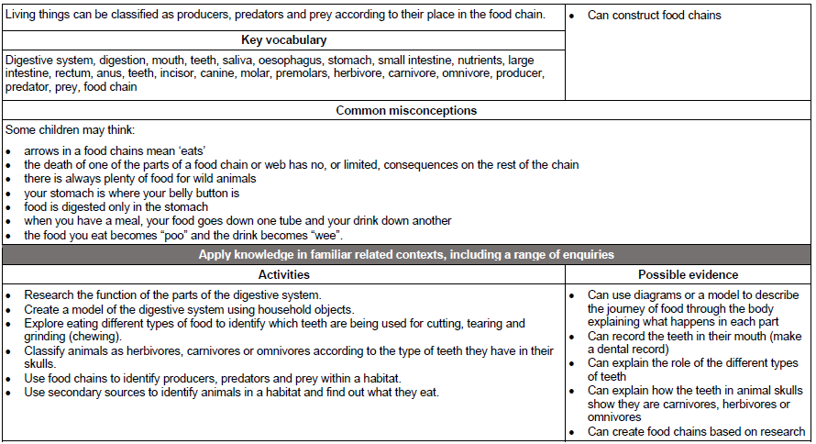

Year 5 – Animals Including Humans

National Curriculum Objectives:
* describe the changes as humans develop to old age.
(Non-statutory:
Pupils should draw a timeline to indicate stages in the growth and development of humans. They should learn about the changes experienced in puberty.)

Prior Learning: | Working Scientifically (NC) Links: | Opportunities for working Scientifically: | Story Opportunities: | Maths Opportunities: | Vocabulary:
In Year 2:  * Notice that animals, including humans, have offspring which grow into adults. | * Research the gestation periods of other animals and comparing them with humans.  * Find out and recording the length and mass of a baby as it grows. | * How and why does the body change?  * How does age affect a human’s reaction time?  * Who grows fastest, girls or boys?  * Can you identify which changes happen at which stage of our life? | * The King Who Banned the Dark  (Emily Haworth-Booth)  * You're Only Old Once!  (Dr. Seuss)  * Hair in Funny Places  (Babette Cole)  * Giant  (Kate Scott) |  | Foetus,  Embryo,  Womb, Gestation,  Baby,  Toddler, Teenager, Elderly,  Growth, Development, Puberty
 | Types of scientific Enquiry:  Fair & Comparative testing  Research using secondary sources  Identifying, classifying & grouping  Pattern seeking  Observing over time |  | Famous Scientists –
In KS3:
* Reproduction in humans, including the structure and function of the male and female reproductive systems, menstrual cycle, gametes, fertilisation, gestation and birth, to include the effect of maternal lifestyle on the foetus, through the placenta.

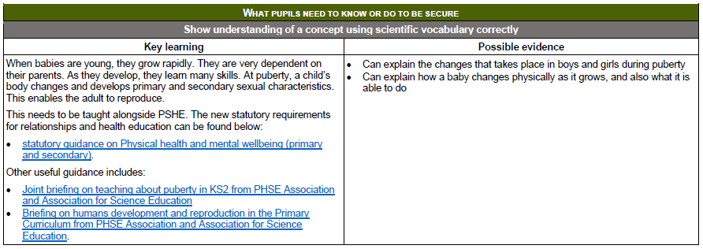
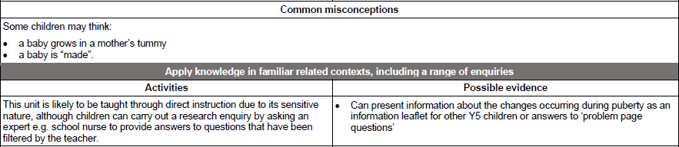
Year 6 – Animals Including Humans

National Curriculum Objectives:
*Identify and name the main parts of the human circulatory system, and describe the functions of the heart, blood vessels and blood.
*Recognise the impact of diet, exercise and drugs and lifestyle on the way their bodies function.
*Describe the ways in which nutrients and water are transported within animals, including humans.

Prior Learning: | Working Scientifically Links: | Opportunities for working Scientifically: | Story Opportunities: | Maths Opportunities: | Vocabulary:
In Year 5:  * describe the changes as humans develop to old age. | * Explore work of scientists and scientific research about the relationship between diet, exercise, drugs, lifestyle and health. | *How does exercise affect our heart rate? This leads to...  * Does your heart rate go up forever?  * Is it the same for adults and children?  *Does your height or weight affect how your heart rate goes up?  * Does exercising regularly affect your lung capacity?  * How can you sort the different organs of the body?  * How much exercise do I do in a week? | A Heart Pumping Adventure  (Heather Manley)  Pig-Heart Boy  (Malorie Blackman)  Skellig  (David Almond)  Famous Scientists –  Justus von Liebig  (Theories of Nutrition and Metabolism)  Sir Richard Doll  (Linking Smoking and Health Problems)  Leonardo Da Vinci  (Anatomy) | Stopwatches  counting  line graphs | Circulatory, Heart, Blood Vessels, Veins, Arteries, Oxygenated, Deoxygenated, Valve, Exercise, Respiration
Types of Scientific Enquiry:
Fair & Comparative testing
Research using secondary sources
Identifying, classifying & grouping
Pattern seeking
Observing over time
IN KS3:
* The consequences of imbalances in the diet, including obesity, starvation and deficiency diseases.
* The effects of the use of recreational drugs on behaviour, health and life processes.
* The structure and functions of the gas exchange system in humans, including adaptations to function.
* The mechanism of breathing to move air in and out of the lungs.
* The impact of exercise, asthma and smoking on the human gas exchange system.

