Year 3 - Forces and Magnets
National Curriculum Objectives:
* Compare how things move on different surfaces.
* Notice that some forces ned contact between two objects, but magnetic force can act at a distance.
* Observe how magnets attract and repel each other and attract some materials but not others.
* Compare and group together a variety of everyday materials on the basis of whether they are attracted to a magnet, and identify some magnetic materials.
* Describe magnets as having two poles.
* Predict whether two magnets will attract or repel each other, depending on which poles are facing.
Prior Learning: | Working Scientifically (NC) Links: | Opportunities for working Scientifically: | Story / Book Opportunities: | Maths Opportunities: | Vocabulary:
In Year 2: Materials:  * Find out how the shapes of solid objects made from some materials can be changed by squashing, bending, twisting and stretching. | * Compare how different things move and group them.  * Raise questions and carry out different tests to find out how far things move on different surfaces; gather and record data to answer these questions.  * Explore the strength of magnets and find a fair way to compare them.  * Sort materials into those that are magnetic and those that are not.  * Look for patterns in the way that magnets behave in relation to each other and what might affect this (e.g. its strength or which poles face each other).  *Identify how these properties make magnets useful in everyday items and suggest creative uses for different magnets. | * How do different surface affect how far a car travels?  * How does the mass of an object affect how much force is needed to make it move?  * Which magnet is strongest?  * Do magnets need to touch for them to work?  * Which ends of the magnet attract / repel?  * Does the size and shape of a magnet affect how strong it is?  * Are all materials magnetic?  * Are magnets the same all the way through?  * If we magnetise a pin, how long will it remain magnetised? | The Iron Man – Ted Hughes  Swim Little Wombat Swim – Charles Fuge  Mrs Armitage: Queen of the Road  (Quentin Blake)  Mr Archimedes’ Bath  (Pamela Allen) | Bar graphs  Displaying data in chart / table | force, push, pull twist, bar, ring, horseshoe, contact force, non-contact force, magnetic, magnetism, attract, repel, magnetic material, poles, metal, iron, steel, north pole, south pole
 | Types of scientific Enquiry:  Fair & Comparative testing  Research using secondary sources  Identifying, classifying & grouping  Pattern seeking  Observing over time |  | Famous Scientists:  William Gilbert  (Theories on Magnetism)  Andre Marie Ampere  (Founder of Electro-Magnetism)
In Year 5:
* Explain that unsupported objects fall towards the Earth because of the force of gravity acting between the Earth and the falling object.
* Identify the effects of air resistance, water resistance and friction, which act between moving surfaces.
* Recognise that some mechanisms, including levers, pulling and gears, allow a smaller force to have a greater effect.

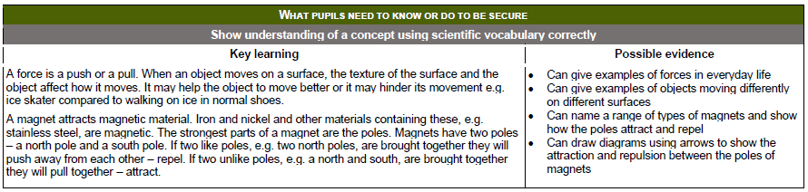

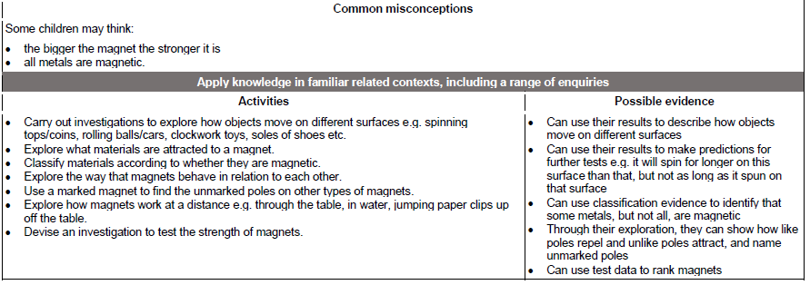

Year 5 - Forces
National Curriculum Objectives:
* Explain that unsupported objects fall towards the Earth because of the force of gravity acting between the Earth and the falling object.
* Identify the effects of air resistance, water resistance and friction, which act between moving surfaces.
* Recognise that some mechanisms, including levers, pulling and gears, allow a smaller force to have a greater effect.
Prior Learning: | Working Scientifically (NC) Links: | Opportunities for working Scientifically: | Story / Book Opportunities: | Maths Opportunities: | Vocabulary:
In Year 3:  * Compare how things move on different surfaces.  * Notice that some forces need contact between two objects, but magnetic force can act at a distance.  * Observe how magnets attract and repel each other and attract some materials but not others.  * Compare and group together a variety of everyday materials on the basis of whether they are attracted to a magnet, and identify some magnetic materials.  * Describe magnets as having two poles.  * Predict whether two magnets will attract or repel each other, depending on which poles are facing. | * Explore falling paper cones or cup-cake cases.  *Make parachutes and carry out fair to tests to determine which designs are the most effective.  * Water resistance – make and explore different shaped boats.  * Design and make products which use pulleys, levers, gears and / or springs and explore their effects. | * How does the size of an object affect the rate that it falls?  * What size wing makes the best sycamore paper helicopter?  * What is the best material to make a parachute out of?  * Does the length of a lever affect the size of a force produced? (Shaduf / trebuchet?)  * How does the surface area of an object affect how long it takes to sink?  * Where do you find gears in the real world?  * Can you label all the forces acting on the object shown?  * How do submarines sink if they are full of air? | The Enormous Turnip  (Katie Daynes)  Leonardo's Dream  (Hans de Beer)  The Aerodynamics of Biscuits  (Clare Helen Welsh)  The Tin Snail  (Cameron McCallister) | Drawing graphs / charts  Measuring distance, time, force | Force, gravity, Earth, air resistance, water resistance, friction, mechanisms, simple machines, levers, pulleys, gears, cog
 | Types of scientific Enquiry:  Fair & Comparative testing  Research using secondary sources  Identifying, classifying & grouping  Pattern seeking  Observing over time |  | Famous Scientists:  Galileo Galilei (Gravity and Acceleration)  Isaac Newton  (Gravitation)  Archimedes of Syracuse  (Levers)
In KS3:
* Forces as pushes or pulls, arising from the interaction between 2 objects.
* Using force arrows in diagrams, adding forces in one direction, balanced and unbalanced.
* Movement as the turning effect of a force.
* Forces associated with deforming objects; stretching and squashing – springs; with rubbing and friction between surfaces, with pushing things out of the way, resistance to motion of air and water.
* Forces measured in Newtons, measurements of stretch or compression as force is changed.
