Year 4 - Electricity

National Curriculum Objectives:
* Identify common appliances that run on electricity.
* Construct a simple series electrical circuit, identifying and naming its basic parts, including cells, wires, bulbs, switches and buzzers.
* Identify whether or not a lamp will light in a simple series circuit, based on whether or not the lamp is part of a complete loop with a battery.
* Recognise that a switch opens and closes a circuit and associates this with whether or not a lamp lights in a simple series circuit.
* Recognise some common conductors and insulators, and associate metals with being good conductors.
IN YEAR 4 – CHILDREN DRAW A PICTORIAL CIRCUIT, THEY DO NOT NEED TO USE CONVENIONLA CIRCUIT SYMOBLS
Prior Learning: | Working Scientifically (NC) Links: | Opportunities for working Scientifically: | Story / Book Opportunities: | Maths Opportunities: | Vocabulary:
IN EYFS:  Children know about similarities and differences in relation to places, objects, materials and living things. They talk about the features of their own immediate environment and how environments might vary from one another. They make observations of plants and animals and explain why some things occur and talk about changes. | * Observe patterns;  - bulbs get brighter if more cells are added,  - that metals tend to be conductors of electricity,  - some materials can and some cannot be used to connect across a gap in a circuit. | * Can you design a decision tree / flow diagram to find the fault in a circuit?  * Can you make a switch?  * Can you identify which circuits will light the bulb?  * What impact on daily life did Thomas Eddison have?  *Sort the materials into electrical conductors and insulators.  * Can you sort these according to their power source?  * Do all batteries hold the same amount of power? | Until I Met Dudley  (Roger McGough)  Oscar and the Bird: A Book about Electricity  (Geoff Waring)  Electrical Wizard: How Nikola Tesla Lit Up the World  (Elizabeth Rusch) | *Venn diagrams -sort appliances run on electricity / batteries / both  * Carroll Diagram - sort conductors / non-conductors / metal/ non-metal  *Decision tree / flow diagram | cell, wire, bulb, switch, buzzer, battery, series, circuit, conductor, insulator electricity, electrical appliance/device, mains, plug, complete circuit, component, positive, negative, connect/connections, loose connection, short circuit, crocodile clip, motor, metal, non-metal
 | Types of scientific Enquiry:  Fair & Comparative testing  Research using secondary sources  Identifying, classifying & grouping  Pattern seeking  Observing over time |  | Famous Scientists:  Thomas Eddison  (First Working Lightbulb)  Joseph Swan  (Incandescent Light Bulb)
In Year 6:
* Associate the brightness of a lamp or the volume of a buzzer with the number and voltage of cells used in the circuit.
* Compare and give reasons for variations in how components function, including the brightness of bulbs, the loudness of buzzers and the on / off position of switches.
* Use recognised symbols when representing a simple circuit in a diagram.

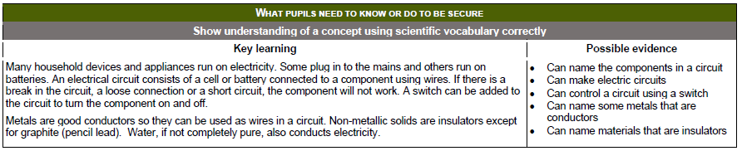

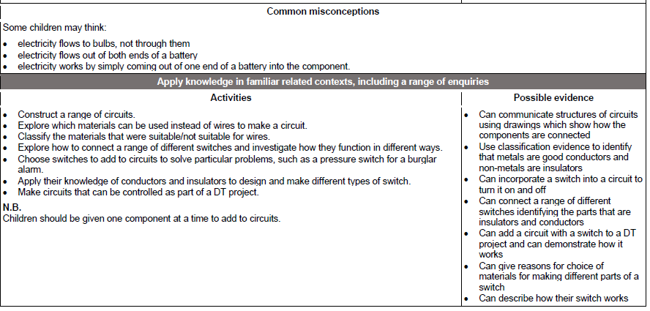

Year 6 - Electricity

National Curriculum Objectives:
* Associate the brightness of a lamp or the volume of a buzzer with the number and voltage of cells used in the circuit.
* Compare and give reasons for variations in how components function, including the brightness of bulbs, the loudness of buzzers and the on / off position of switches.
* Use recognised symbols when representing a simple circuit in a diagram.
Prior Learning: | Working Scientifically (NC) Links: | Opportunities for working Scientifically: | Story / Book  Opportunities: | Vocabulary:
In Year 4:  * Identify common appliances that run on electricity.  * Construct a simple series electrical circuit, identifying and naming its basic parts, including cells, wires, bulbs, switches and buzzers.  * Identify whether or not a lamp will light in a simple series circuit, based on whether or not the lamp is part of a complete loop with a battery.  * Recognise that a switch opens and closes a circuit and associates this with whether or not a lamp lights in a simple series circuit.  * Recognise some common conductors and insulators, and associate metals with being good conductors. | * Work systematically to identify the effect of changing one component at a time in a circuit.  * Design and make a set of traffic lights, a burglar alarm or another useful circuit. | * What happens to the ….. if……  - volume of a buzzer if I increase / decrease the thickness of wires?  - volume of a buzzer if I increase / decrease length of wires?  - brightness of bulb if I increase / decrease the voltage of the cells?  - speed of a motor if I increase / decrease the number of bulbs?  - speed of a motor if I increase / decrease the number of cells?  * Which circuits will work? Can you fix those that don’t?  *Can you draw an accurate diagram of the circuit?  * Which types of fruit make the best fruit battery?  * How could you group electrical components based on their role?  * How has our understanding of electricity developed over time?  * How does the brightness of a bulb change over time? | Goodnight Mr Tom  (Michelle Magorian)  Blackout  (John Rocco)  Hitler’s Canary  (Sandi Toksvig) | circuit, complete circuit, circuit symbol, volts, voltage, amps
 | Types of scientific Enquiry:  Fair & Comparative testing  Research using secondary sources  Identifying, classifying & grouping  Pattern seeking  Observing over time |  | Famous Scientists:  Alessandro Volta (Electrical Battery)  Nicola Tesla  (Alternating Currents)
In KS3:
* Electric currents, measured in amperes, in circuits in series and parallel circuits, currents add where branches meet and current as flow of change.
* Potential difference measured in volts, battery and bulb ratings; resistances measured in ohms, as the ration of potential difference ((p.d) to current.
* Differences in resistance between conducting and insulating components.
* Static electricity.

