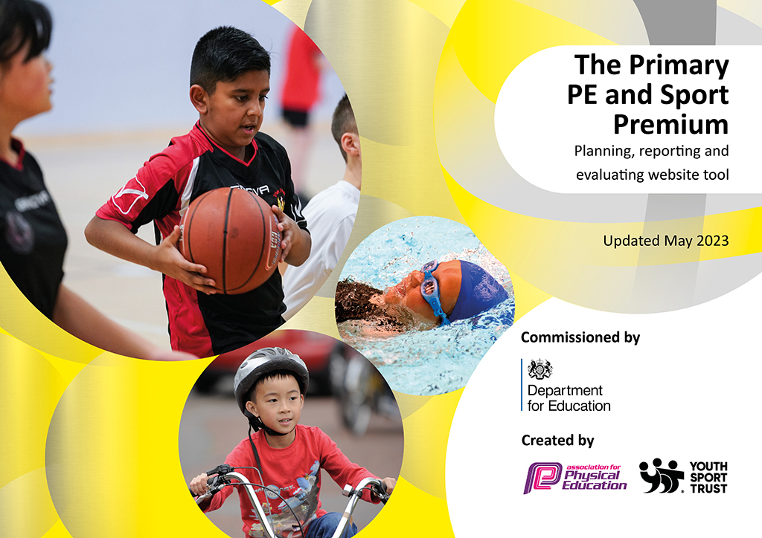
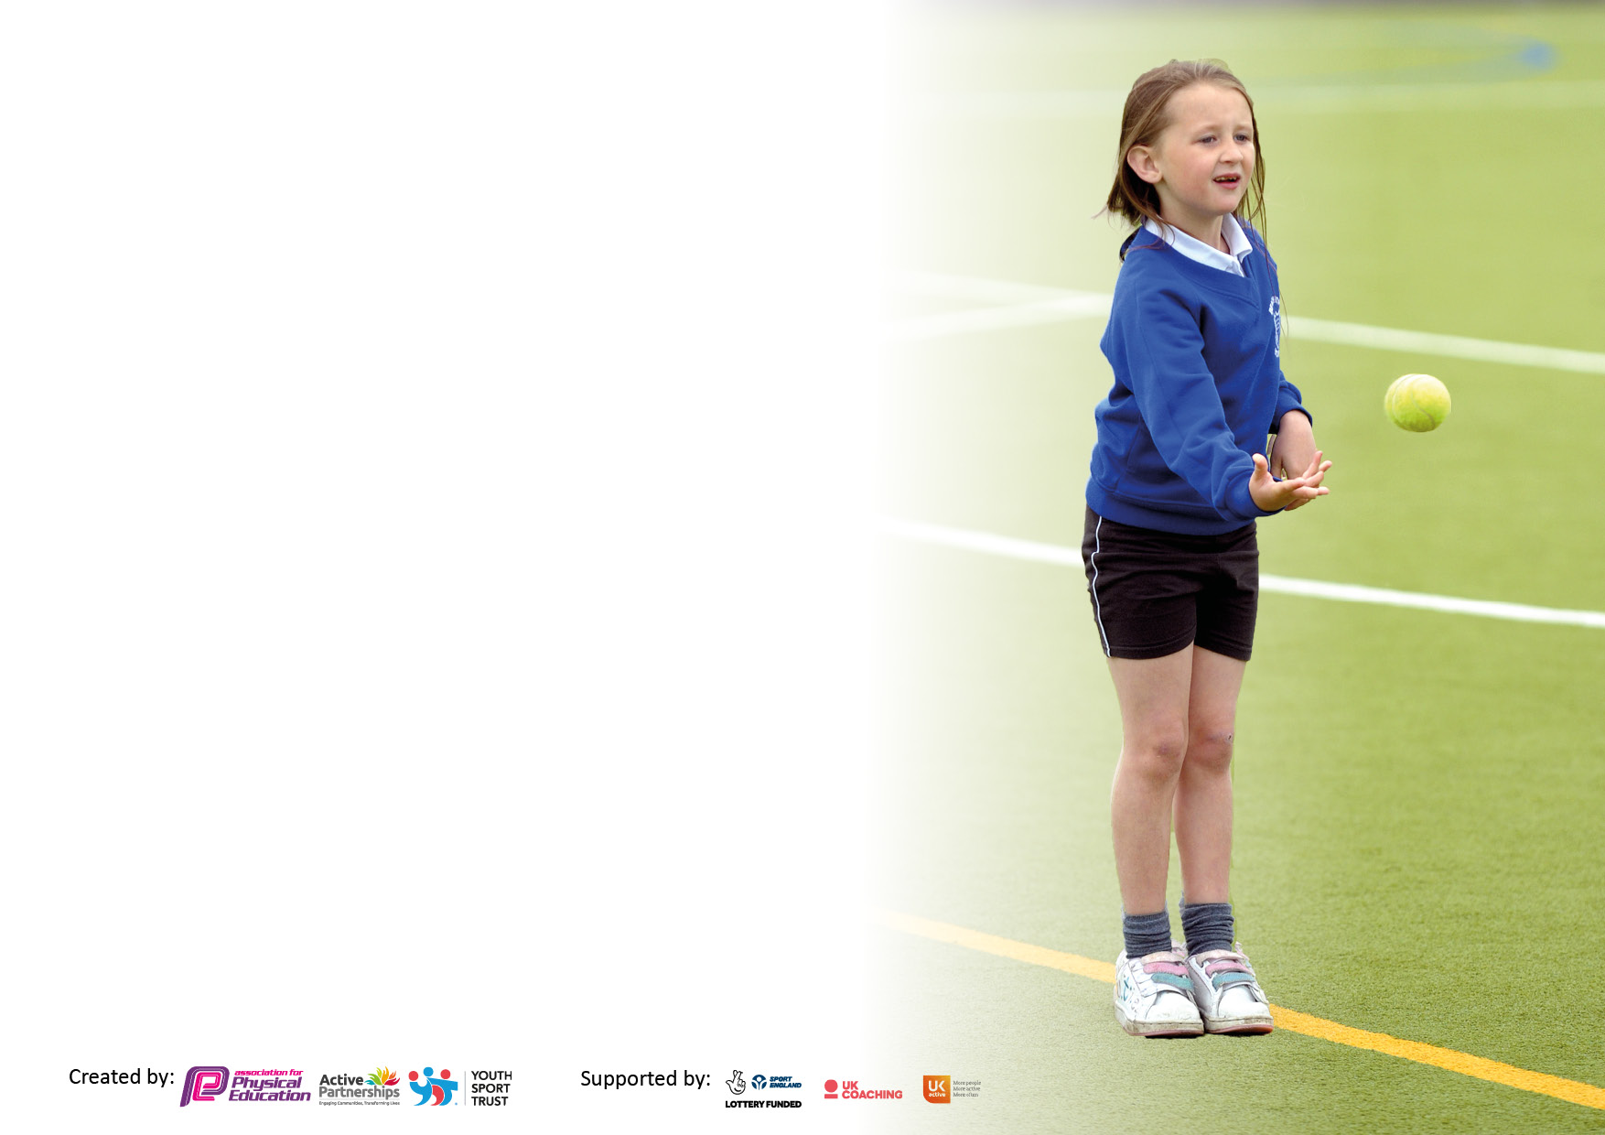

It is important that your grant is used effectively and based on school need. The Education Inspection Framework makes clear there will be a focus on ‘whether leaders and those responsible for governors all understand their respective roles and perform these in a way that enhances the effectiveness of the school’.

Under the Quality of Education Ofsted inspectors consider:
Intent - Curriculum design, coverage and appropriateness
Implementation - Curriculum delivery, Teaching (pedagogy) and Assessment
Impact - Attainment and progress

To assist schools with common transferable language this template has been developed to utilise the same three headings which should make your plans easily transferable between working documents.

Schools must use the funding to make additional and sustainable improvements to the quality of Physical Education, School Sport and Physical Activity (PESSPA) they offer. This means that you should use the Primary PE and sport premium to:

- Develop or add to the PESSPA activities that your school already offer
- Build capacity and capability within the school to ensure that improvements made now will benefit pupils joining the school in future years
- The Primary PE and sport premium should not be used to fund capital spend projects; the school’s budget should fund these.

Pleasevisitgov.ukfortherevisedDfEguidanceincludingthe5keyindicatorsacrosswhichschoolsshoulddemonstrate animprovement.Thisdocumentwillhelpyoutoreviewyourprovisionandtoreportyourspend.DfEencouragesschools to use this template as an effective way of meeting the reporting requirements of the Primary PE and Sport Premium.

We recommend you start by reflecting on the impact of current provision and reviewing the previous spend.

Schools are required to publish details of how they spend this funding, including any under-spend from 2021/2022, as well as on the impact it has on pupils’ PE and sport participation and attainment. All funding must be spent by 31st July 2023.

We recommend regularly updating the table and publishing it on your website throughout the year. This evidences your ongoing self-evaluation of how you are using the funding to secure maximum, sustainable impact. Final copy must be posted on your website by the end of the academic year and no later than the 31st July 2023. To see an example of how to complete the table please click HERE.

Details with regard to funding
Please complete the table below.

Total amount carried over from 2021/22 | £711.78
Total amount allocated for 2022/23 | £19,583.00
How much (if any) do you intend to carry over from this total fund into 2023/24? | £0
Total amount allocated for 2022/23 | £20,294.78
Total amount of funding for 2022/23. To be spent and reported on by 31st July 2023. | £20,600.82
Swimming Data
Please report on your Swimming Data below.

Meeting national curriculum requirements for swimming and water safety.

N.B. Complete this section to your best ability. For example you might have practised safe self-rescue techniques on dry land which you can then transfer to the pool when school swimming restarts.
Due to exceptional circumstances priority should be given to ensuring that pupils can perform safe self rescue even if they do not fully meet the first two requirements of the NC programme of study
What percentage of your current Year 6 cohort swim competently, confidently and proficiently over a distance of at least 25 metres?  N.B. Even though your pupils may swim in another year please report on their attainment on leaving primary school at the end of the summer term 2022.  Please see note above | 60%
What percentage of your current Year 6 cohort use a range of strokes effectively [for example, front crawl, backstroke and breaststroke]?  Please see note above | 68%
What percentage of your current Year 6 cohort perform safe self-rescue in different water-based situations? | 80%
Schools can choose to use the Primary PE and sport premium to provide additional provision for swimming but this must be for activity over and above the national curriculum requirements. Have you used it in this way? | Yes

Action Plan and Budget Tracking
Capture your intended annual spend against the 5 key indicators. Clarify the success criteria and evidence of impact that you intend to measure to evaluate for pupils today and for the future.

Academic Year: 2022/23 | Total fund allocated: £20,600.82 | Date Updated: 24/07/23
Key indicator 1: The engagement of all pupils in regular physical activity – Chief Medical Officers guidelines recommend that primary school pupils undertake at least 30 minutes of physical activity a day in school |  |  |  | Percentage of total allocation:
 |  |  |  | 35.2%
Intent | Implementation |  | Impact
Your school focus should be clear what you want the pupils to know and be able to do and about  what they need to learn and to  consolidate through practice: | Make sure your actions to achieve are linked to your intentions: | Funding allocated: | Evidence of impact: what do pupils now know and what can they now do? What has changed?: | Sustainability and suggested next steps:
To consolidate swimming skills for our Year 6 children. | Additional swimming lessons targeted at poor swimmers to increase confidence and ability beyond their current levels. | £1256.25 | Increase in children who show both confidence and ability to swim without aids and over the 25m required by the NC. | We will continue this as part of our offering for 23/24
To target disengaged children to engaged in more physical activity at lunchtimes. | Weekly lunchtime club for less engaged children in PE lessons, identified by teachers. | £900 | Slight increase in the attending children being engaged in physical activity however children still lacked engagement. | We have bought into OPAL so that we can provide opportunities for all children across school to be involved in physical activity at lunchtime.
To engage more children in physical activity during lunchtimes through play. | OPAL initial set up to provide a wide range of activities/ play equipment for the children to use during lunchtimes. | £4999 | The children’s attitude to lunchtime activities has changed as they now have equipment that they can use to be physically active and it has a greater level of choice than what was previously provided. | We are going to continue to use OPAL to provide opportunities for all children across school to be involved in physical activity at lunchtime.
To further support non swimmers in year 4. | An additional instructor due to the number of non-swimmers and the more specialized provision we could offer to the children. | £100 | This enabled the non-swimmers to make more progress and allowed for them to gain confidence in being in the water. | We will judge this on the needs of the children in the future and how many non-swimmers we have.
Key indicator 2: The profile of PESSPA being raised across the school as a tool for whole school improvement |  |  |  | Percentage of total allocation:
 |  |  |  | 0.2%
Intent | Implementation |  | Impact
Your school focus should be clear what you want the pupils to know and be able to do and about  what they need to learn and to  consolidate through practice: | Make sure your actions to achieve are linked to your intentions: | Funding allocated: | Evidence of impact: what do pupils now know and what can they now do? What has changed?: | Sustainability and suggested next steps:
To maintain high expectations when attending competitions by having members of staff match the children’s uniform. | Additional kit for competitions | £30.65 | Children have more respect for their appearance at competitions because of the staff reinforcing the high expectations of the school. | We will continue to monitor the impact that this has on the children’s attitudes at competitions.

Key indicator 3: Increased confidence, knowledge and skills of all staff in teaching PE and sport |  |  |  | Percentage of total allocation:
 |  |  |  | 38.3%
Intent | Implementation |  | Impact
Your school focus should be clear | Make sure your actions to | Funding | Evidence of impact: what do | Sustainability and suggested
what you want the pupils to know | achieve are linked to your | allocated: | pupils now know and what | next steps:
and be able to do and about | intentions: |  | can they now do? What has
what they need to learn and to |  |  | changed?:
consolidate through practice:
To enable the staff to increase their confidence and ability to teach a wider range of physical activities and sports to a higher level, thereby increasing the quality first learning opportunities for the children to excel. | Get set 4 PE whole school subscription | £750 | Planning is simplified and easier for teachers to follow meaning that they feel more confident in delivering this and there is a greater focus on adapting the learning to meet the children’s needs. | Teachers will continue to use Get set 4 PE and the subject leader will support with further training on how to adapt the learning to challenge and scaffold the children during PE lessons.
To improve the PE provision for KS1 and EYFS. | Bought into Get Set 4 PE for EYFS and KS1 on a trial basis. | £340 | This worked incredibly well for both EYFS and KS1 as the plans were easier to follow and it engaged the children. | We have since bought into this across the school and are going to continue to use this as guidance for our teachers.
To improve the leadership skills of new subject leader so that he can effectively support staff. | L5 and L6 Physical Education Primary specialism course | £995 | Subject leader has supported staff with the teaching of PE and has developed the curriculum as a result of training which is ongoing. | Subject leader should show increased knowledge and understanding of leading PE, being able to support staff in developing their confidence and knowledge of teaching PE.
Staff to be more confident in the teaching of PE and will better be able to adapt learning to meet the needs of all pupils. | Support from the MKNSSP including a whole day each half term of one to two teacher support with all members of staff. | £4000 and £300 affiliation | Teachers have shown greater confidence in adapting planning to meet the pupil’s needs and have responded to feedback. | We are going to continue to use the MKNSSP next year but will decide what level of support we will require from the MKNSSP.
Early career teachers will develop their knowledge of teaching PE. | A member of Premier Education to teach ECT teachers PE for a term so the ECT can learn from them and then a follow up term where the ECT will teach with feedback and support from Premier staff | £800 | Early career teachers have developed their knowledge of PE and have responded to feedback effectively. | We are not going to continue this next academic year as we have no year 1 ECT’s
Improve the skills progress throughout school following planning that is highly skill based. | PE passport to enable teachers to focus on key skills they need to teach. | £699 | This had an impact on the level of skill that the children were showing during PE lessons however was pitched at a level that was too high for EYFS and KS1 | We have decided to replace this with Get Set 4 PE planning across school after trialing it in EYFS and KS1.
Key indicator 4: Broader experience of a range of sports and activities offered to all pupils |  |  |  | Percentage of total allocation:
 |  |  |  | 15.2%
Intent | Implementation |  | Impact
Your school focus should be clear | Make sure your actions to | Funding | Evidence of impact: what do | Sustainability and suggested
what you want the pupils to know | achieve are linked to your | allocated: | pupils now know and what | next steps:
and be able to do and about | intentions: |  | can they now do? What has
what they need to learn and to |  |  | changed?:
consolidate through practice:
To introduce groups of children to the new sport of climbing.  Additional achievements: | Climbing lessons at our local climbing centre for targeted groups of children. | £1,489.58 | Children showed a more positive attitude towards Physical activity. Helped to develop children’s resilience and determination as well as giving children a chance to experience a new sport. | Based on the positive impact that this has had on the children. We are going to continue to offer this in our PE programme.
To provide more opportunities for our children to experience a range of sports and activities during school time and extra-curricular clubs | Equipment to allow children to experience a wider range of sports and activities. | £517.55 | Children have been exposed to sports such as ultimate Frisbee that they may not have heard of before. The children showed a real engagement during these sessions. | We have now sourced the equipment for these sports and will continue to work to expose the children to an even wider variety of sports and activities.
To enhance the gymnastics learning for all by providing a better quality range of heights for all age groups to access. | Agility apparatus | £730.10 | Children have shown more confidence during gymnastics as they had a better quality range of heights to use during lessons. | To make sure that these are used in more gymnastics lessons across school.
To provide greater opportunities for physical activity for our EYFS pupils with SEND. | Montessori wooden Climbing set | £393.69 | Children have shown an increase in courage, hand-eye coordination and balance control. | This has really been utilized in our EYFS provision and shown how important it is to continue to invest in specialized provision of our EYFS children with SEND.

Key indicator 5: Increased participation in competitive sport |  |  |  | Percentage of total allocation:
 |  |  |  | 11.2%
Intent | Implementation |  | Impact
Your school focus should be clear | Make sure your actions to | Funding | Evidence of impact: what do | Sustainability and suggested
what you want the pupils to know | achieve are linked to your | allocated: | pupils now know and what | next steps:
and be able to do and about | intentions: |  | can they now do? What has
what they need to learn and to |  |  | changed?:
consolidate through practice:
To increase opportunities for children to compete in a range of competitive sports competitions | 1x weekly club for more able children linked to a local interschool competition. | £1,500 | Children have been engaged and developed their confidence in competing at competitions. | We are continuing to join the Premier sport competitions and are going to use this as a method for getting more children involved in sport instead of the more able children as that is being targeted by the MKNSSP events package.
To enable children to compete in local competitions that are pitched at a higher sporting ability. | MKNSSP events package | £800 | Children have engaged in a wider variety of sports at competition level which has increased their confidence and improved the sporting opportunities that we provide the children. | We are going to continue to use the MKNSSP events packages next year as this is part of an ongoing development of our PESSPA

Signed off by
Head Teacher: | Nick Hearn
Date: | 24/07/23
Subject Leader: | Brandon Patterson
Date: | 24/07/23
Governor: | Curriculum Committee
Date: | 12/06/23

